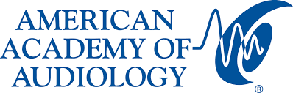
PRESS CREDENTIAL FORM

AAA2023 + HearTECH Expo April 19-22, 2023

Seattle Convention Center—Arch Building
705 Pike Street
Seattle, Washington 98101-2310

Press credentials for the AAA 2023+HearTECH Expo on April 19–22, 2023 are limited and will be issued at the discretion of the American Academy of Audiology. Admission to the press is restricted to those issued press credentials via this form.

AAA2023 will present cutting-edge basic, clinical, technical and audiological research. Through featured sessions, learning labs, research and poster presentations, attendees will hear from world-renowned leaders in the field of audiology.

The annual conference will be held April 19-22 in Seattle, Washington. Press credentials allow media to attend featured sessions, learning labs, research and poster presentations, the HearTECH Expo, as well as free networking events and activities. Media may also attend paid events but must register and pay during the registration process. Please note: Media are not permitted to earn CEUs nor to attend board and committee meetings.

Schedules for the meeting may be found here:

- Schedule at a Glance: https://www.audiology.org/education-and-events/aaa-annual-conference/program-and-events/schedule-at-a-glance/

- HearTECH Expo Schedule: https://www.audiology.org/education-and-events/aaa-annual-conference/exhibit-hall/heartech-expo-schedule/

If you would like to be credentialed for the conference, please complete the form below:

(Print full name) (Signature)

(News Organization) (Address)

(Phone number) (Email Address)

(Assignment Editor) (Phone Number)

Return this completed form to Kiersten Valko at kvalko@audiology.org. For questions, please email Vicki Bendure at Vicki@bendurepr.com or call/text 202-374-9259.

For more information on the conference, schedules and hotels visit www.AAAConference.org.

