CE Provider Course Submission Requirements Guide
As a reminder, please contact the Academy for any changes to your Provider Organization account. This includes, but is not limited to, the Organization Name, Provider Contact, or email address. All changes must be updated directly by the Academy for the login and account to function correctly.
STOP if all your course documents are not completed in full and you are not prepared to sit and complete the course at that time. You are unable to start and stop or return to your course to complete any missing information.
If you have any questions regarding the course submission process, reach out prior to beginning your course to avoid an incomplete course submission. Please refer to the Academy’s website or email continuingeducation@audiology.org.

To access the CE Provider portal from the Academy website, you will log into your Dashboard, locate the My Organization header and select Academy CE Provider Portal.
Step 1: Go To www.audiology.org
Step 2: Select Member Login in the top right corner of the screen
Please enter your ID number or Member ID number for Username and your Email Address or the Password you created for the Password. If you do not know your Password, you may reset your password or contact the Academy to reset it.
Step 3: Once logged in, click on My Account. This will direct you to your Member Dashboard page.
Step 4: Locate My Organization
Select Academy CE Provider Portal from the left column on the page
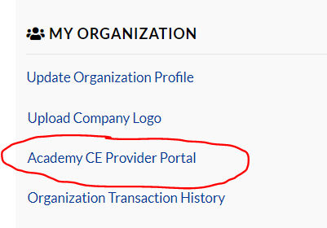
OR
By selecting CE Provider Portal at the top of the page.


To begin, select Submit New Course
Please complete the course steps in order and fill in all required data.
If you try to go back a page to add information, the course could submit before you are ready or may show an error. You will need to restart you course over.



CE Provider Information

This information will be already filled in with your Provider information. If you are not the Provider contact on file for your Organization, please do not continue and contact the Academy.

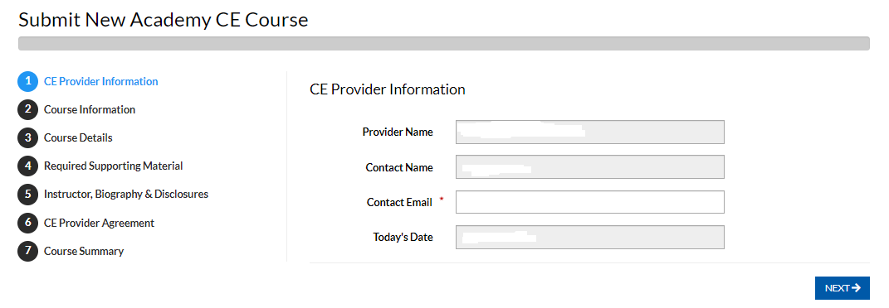

Course Information

- Program Title: The course title should appear the same everywhere it is used, including on your reporting form.
- Instructional Level: Choices are Introductory, Intermediate or Advanced
- Format of course: Options are In-person, Online/Live (streaming), On-demand (recorded) or Text Course
- Program Focus: Options are Knowledge or Skills

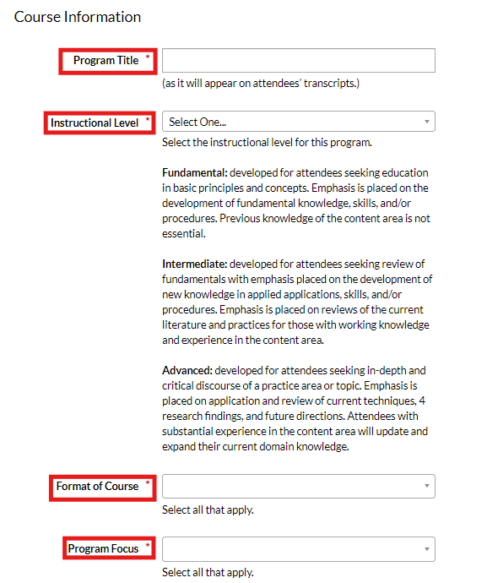

- Type of Training: Options are Clinical, Other or Practice Management
- Needs Analysis: Please see text under the box for the requirement.
- Purpose of Program: Please be specific.

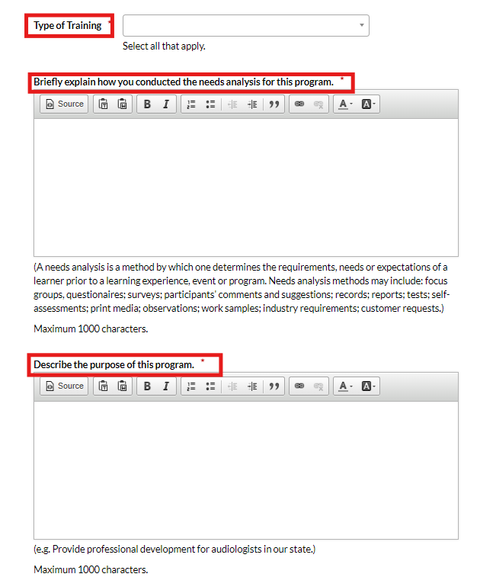

- Verifying Attendance: Providers must be able to track attendee participation at all times.
- Supporting Materials: Possible choices below the text box.

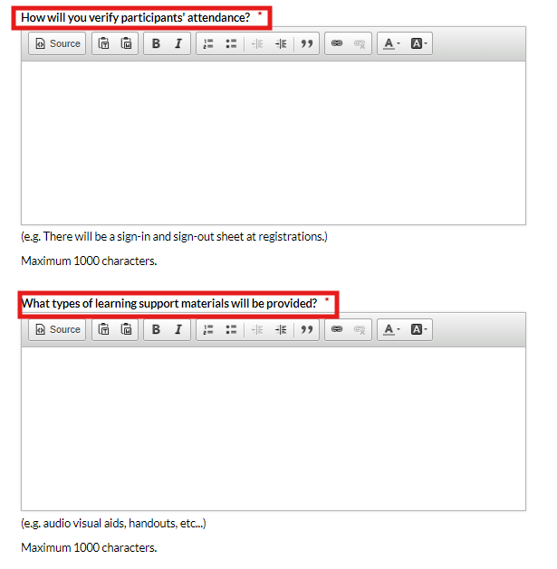

- Education Facility – Please provide detailed information regarding each format offered, with the location and dates for each format (i.e., an individual date for in-person or online or online/on-demand for a period of time (no greater than 3 months) and whether it will be monthly or quarterly reporting). Quarterly reporting requires individual completion dates for each attendee.
- CEUs amount offered. Common increments of CEUs: 30 minutes = 0.05 CEUs, 1 hour = 0.1 CEUs, 2.5 hours = 0.25 CEUs, 5 hours = 0.5 CEUs, 10 hours = 1.0 CEUs. The Academy does not approve CEUs in increments of 15 minutes.
For further assistance, please see page 4 of the Academy’s guidelines and requirements.

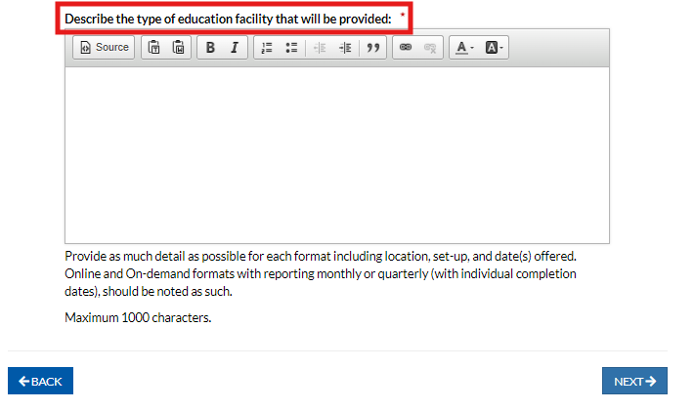
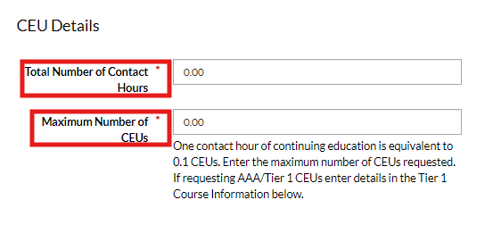

- Tier 1 CEUs: Provider’s choice regarding how the course will be offered. *There is a Tier 1 fee to offer CEUs and should be paid at the time of course submission. See page 10 of the Academy’s guidelines and requirements for additional assistance.

Tier 1 course Yes or No options
NO:
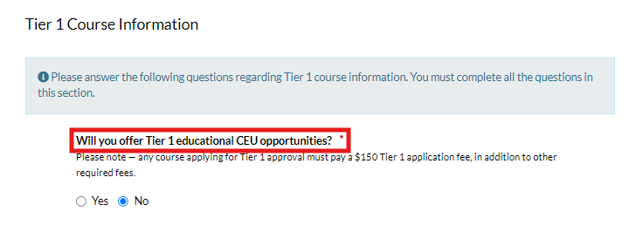
YES:
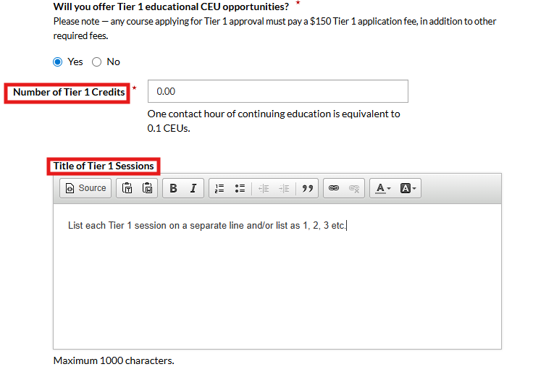

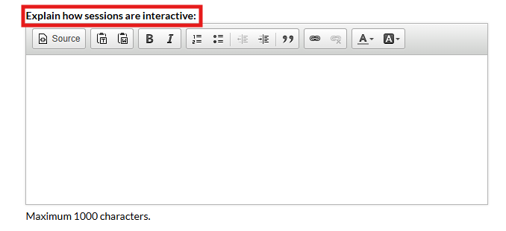

Course Details

- Start Date – start date of first course offered. Reporting submitted prior the start date will not be accepted.
- End Date –The end date should be no later than 12/31 of the current year. Courses are approved for the calendar year only and should not overlap into the next year.
- Location: city/state for in-person courses, or enter online or on-demand for the city with no state selected. Various location acceptable for multiple formats.

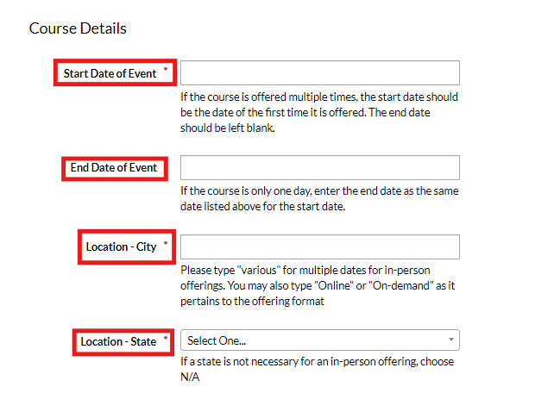

- Target Audience: Options are Audiologists, Hearing Aid Dispensers, Others, Students
- Registration: enter any registration fees associated with completing this course

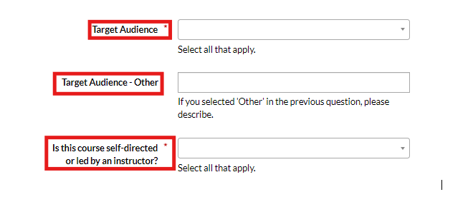

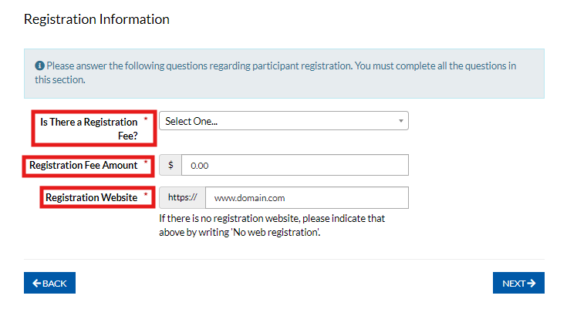

Required Supporting Course Materials

Provider documents for uploading to the portal:
- Please be aware there is a character limit for the attachment file names; they should not contain any special characters.

If the system should pause after you hit the submit button to upload your document, please allow the system time to process the upload so you can proceed. Do not hit submit again or the course could possibly submit as incomplete.

Please do not keep hitting submit as this will cause internal issues; your document may not show as uploaded and it will blank for the Academy’s review/approval.

Please do not provide a website link in place of the actual required course information.

- Learner Outcomes Agenda Template:
The required Agenda Template must be completed. The template and template completion instructions are on the Academy’s website here.
  - Make sure that all columns are spaced out so all data can be easily read and remove any instructions so only your data is visible.

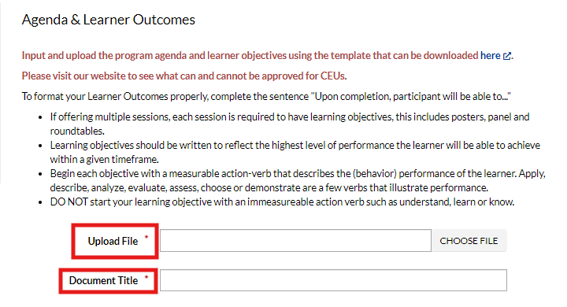

- Assessment:
The assessment should be questions that measure the learning of the course material, and based on the learner outcomes.

The requirement for this area is noted below the text box. Please state the assessment is based on the learner outcomes.

Example wording for use: “Assessment questions will be provided to the course attendees to access learning of the course materials and will be based on the learner outcomes.”

*The assessment is not the same as an evaluation. This form is one of two forms that should be completed by your attendees to receive CEUs. The other is the evaluation.

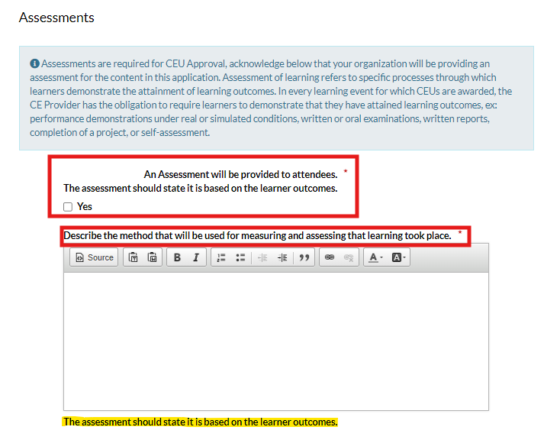

- Evaluation:
Providers should create their own course evaluation.
This can be a rating scale, questions or a mix of both, and should be related to overall satisfaction of the course in relation to the content, speakers and presentation, location, etc.

*The evaluation is not the same as an assessment. This form is one of two forms that should be completed by your attendees to receive CEUs. The other is the assessment.

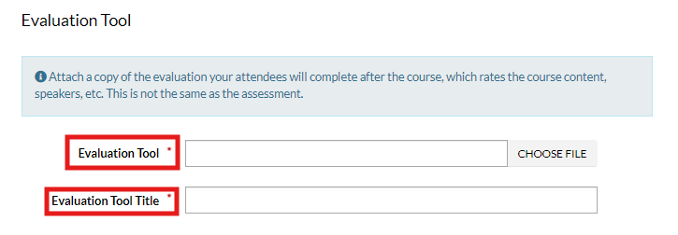

- Required Academy Paragraph and Logo:

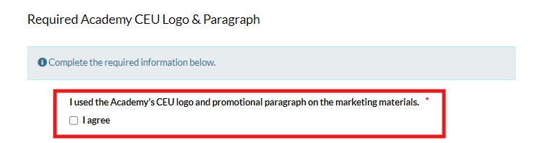

- Marketing:
This can be a save the date postcard, flyer, or a full brochure. The Academy logo and paragraph must be included on ALL course marketing or promotional materials including any emails, and the on the Providers website, etc.

The most up to date version of the Academy paragraph and logo can be found on the Academy’s website here.

Additional supporting documents would be for any additional information outside of the required information provided.

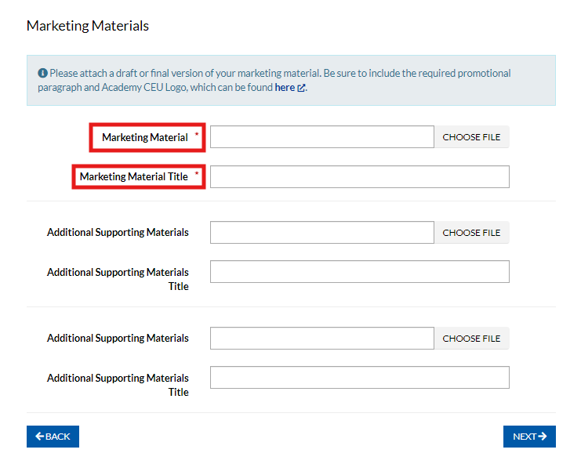

- Instructor, Biography and Disclosures:
Speaker bios and disclosures must be completed for each presenter, preferably in order of presentation or ABC.

Please combine all speaker info into one document for the upload, the bio followed by the disclosures under the bio. They cannot be uploaded separately.

Please avoid a complete outline of the course agenda with learner outcomes for the speaker info. A short bio and the disclosure info is sufficient. You must note any conflict of interest and state specifically whether any of your speaker have anything to disclosure or they if do not have anything to disclose.

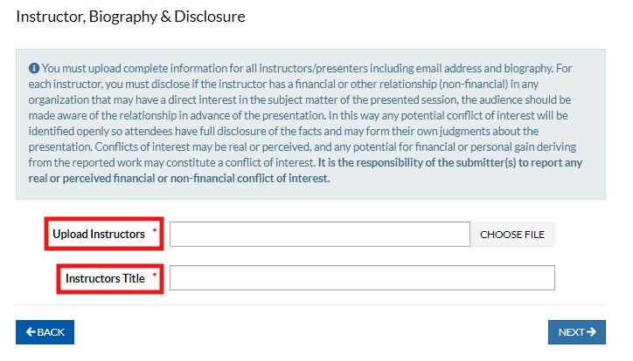

- CE Provider Agreement:
By checking this box, your organization agrees to follow the Academy’s policies and guidelines and meet the responsibilities outlined in the agreement. You’re also confirming that you’ve read and understand the information below, especially regarding any additional fees you may be responsible for.

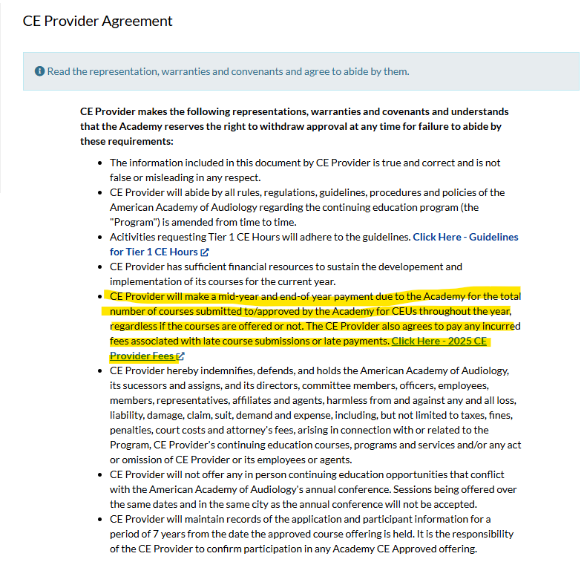

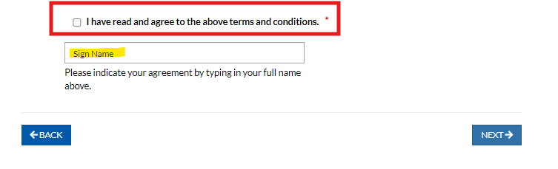

- Course Summary:

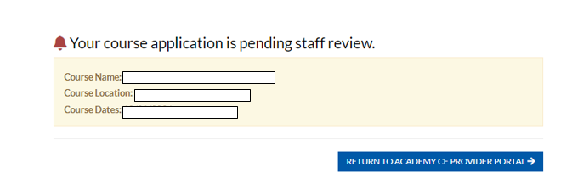

Congratulations, you course has been submitted for review and Academy approval!

