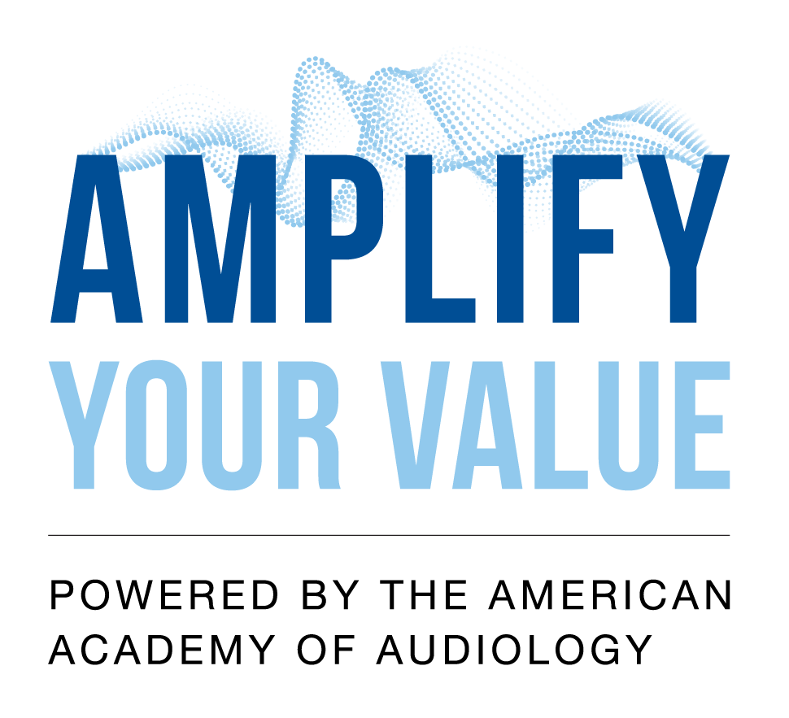
{BUSINESS NAME}
oVEMP
{BUSINESS ADDRESS}

Note: *** denotes where you will input your own data

Ocular Vestibular Evoked Myogenic Potential (oVEMP) Evaluation
VEMP is no longer considered an experimental or investigational procedure as it currently meets Category I codes which requires FDA approval.
The Category I codes were created by the American Medical Association’s code process which were effective on January 1, 2021.
Results: ***
History: {NAME} presents for Ocular Vestibular Evoked Myogenic Potential (oVEMP) evaluation referred by Dr. *** with chief complaint of ***. The patient reports onset of *** approximately *** ago with most recent episode occurring ***. The patient denies autophony, increased perception of internal body sounds, and dizziness with loud sound, exertion, coughing/sneezing and altitude changes. Most recent audiogram on *** illustrates ***. VEMP testing is being conducted to further assess otolith and vestibular nerve function.
Clinical use: Ocular vestibular evoked myogenic potentials (oVEMPS) are auditory-evoked brainstem potentials which assess the function of the utricle and superior vestibular nerve. Ocular VEMP response amplitude has also been shown to significantly increase in the presence of superior semicircular canal dehiscence (SSCD) and serves as a sensitive/specific screening for SSCD. Please note amplitude cutoff values below for SSCD screening.
Equipment/supplies: {EQUIPMENT NAME}, {SOFTWARE}, patient test cable and surface electrode leads, disposable surface electrodes, insert earphone transducer cable and insert earphones, and the following skin prep materials: ***
Procedure: Test procedures and instructions were given to the patient prior to electrode placement and testing. The patient was given the opportunity to ask any questions about the procedure and to have those questions answered. The patient appeared to understand the procedure and instruction details.
Skin was appropriately prepped for electrodes. Electrodes were placed as follows: (1) Non-inverting electrode placed infraorbitally (lower corner of contralateral eye, directly below the lashline ), (2) inverting electrode placed on forehead between eyebrows, and (3) ground placed on forehead approximately 2cm above inverting electrode. Impedance was verified to be below 5Ω for all electrodes. Testing was completed with the patient in the seated position with chin level (not up or with head back) The patient was asked to avert their gaze up and midline at a visual target placed at least 30 degrees. Stimulus was presented unilaterally with 500 Hz and/or 4000 Hz toneburst stimulus (without contralateral masking) for 50+ sub-averages. Responses were obtained from infraorbital eye muscle contralateral to the stimulated ear. Testing was completed in both ears. Ocular VEMP responses were repeated at least once to verify replicability. If clear/replicable morphology was not initially obtained despite several runs, control runs were completed with transducer disconnected to rule out stimulus artifact in patient response.
Procedure was completed by an audiologist licensed in the state of ***, holding a Doctorate of Audiology. This procedure is an independent billable procedure. Usual and customary fee for the oVEMP procedure from this facility's fee schedule is viewable on billing invoice.
oVEMP Test Parameters:
500Hz Toneburst Stimulus: ***
Polarity Alternating
Rate: *** mSec
Artifact Reject ON (*** uV)
Electrode Impedance Right: *** Left: ***
Waveform Morphology Right: *** Left: ***
Otoscopic examination revealed ***
Test Results: ***
Test Results: ***
Ocular Vestibular Evoked Myogenic Potentials (oVEMP)
500Hz Tone Burst at *** dBSPL
Right ear: ***
Left ear: ***
Difference between right and left ear *IAR: ***
N1-P1 Amplitude (microV) AR = *** AL= *** *** ***%
(Normal IAR < 30%)
*IAR = Interaural Amplitude Ratio = |AL - AR| x 100
AL + AR
Ocular Vestibular Evoked Myogenic Potentials (oVEMP)
4000Hz Tone Burst at *** dBSPL
Right ear: ***
Left ear: ***
Absent = ***
(normal; negative SSCD screening)
Present = ***
(abnormal; positive SSCD screening)
Interpretation:
Ocular VEMP test results consistent with present***/***symmetrical utricular and/or superior vestibular nerve function in *** ear.
OR
Today’s testing did not yield a measurable ocular VEMP test result. This may be due to ***.
SSCD Screening:
Compared to normative cutoff data below, the patient's oVEMP response amplitudes are ***, suggesting positive***negative superior semicircular canal dehiscence screenings in *** ear.
OR
Normative cutoff data is not available for the patient's age decade; however, the patient's oVEMP response amplitudes are noted to be *** for the *** age decade, suggesting positive/negative*** superior semicircular canal dehiscence screenings in *** for the *** age decade.
N1-P1 Cutoff values for SSCD screening
Age decade Cutoff value (uV)
30s >17.5
40s >22
50s >16.6
60s >14.8
*Zuniga, M.G., Janky, K.L., Nguyen, K.D., Welgampola, M.S., and Carey, J.P. (2013). Ocular versus cervical VEMPs in the diagnosis of superior semi-circular canal dehiscence syndrome. Otology and Neurology, 34,121-126
Recommendations:
1. Follow up with Dr. ***.
2. Call this clinic with any questions or concerns about today’s testing results.
Cc: Dr. ***

Total time spent on procedure: ***
Start time: ***
End time: ***

